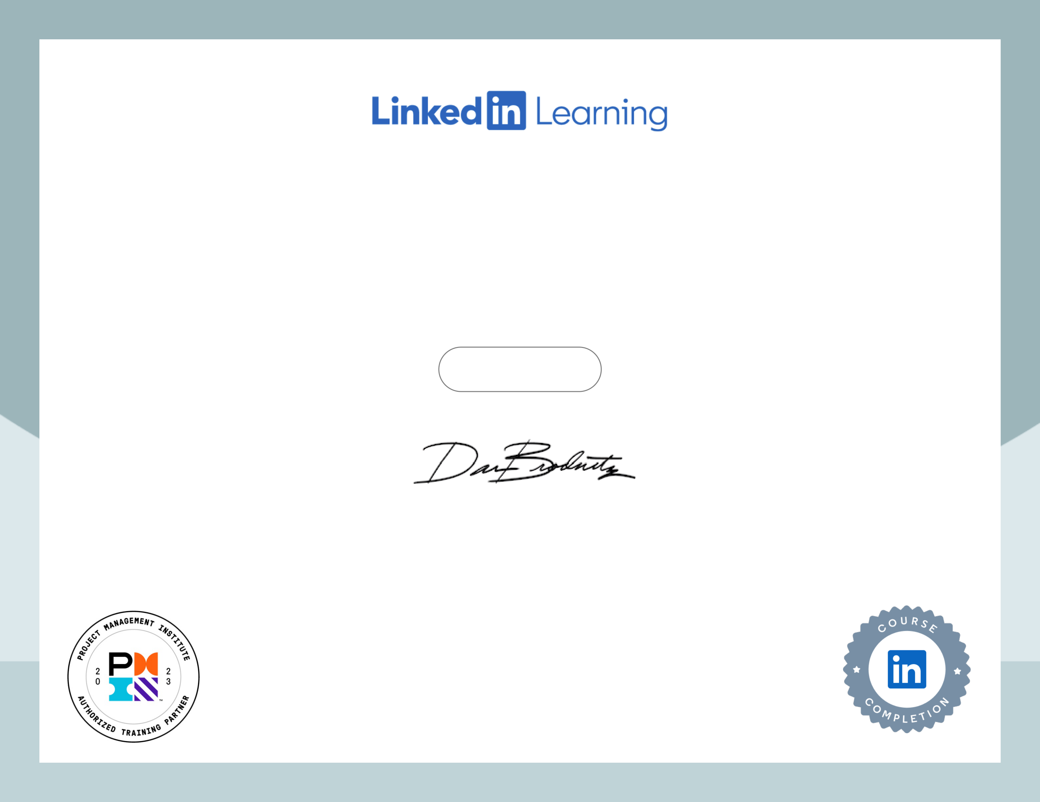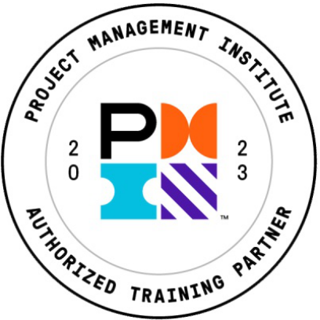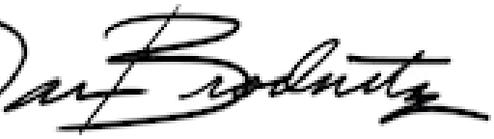

Holding Yourself Accountable Course completed by Pawandeep Thandi

Nov 25, 2024 at 03:56PM UTC

Top skills covered

Accountability

Head of Global Content, Learning

Program: PMI® Registered Education Provider   
 Provider ID: #4101   
 Activity #: 4101EQC7EV   
 PDUs/ContactHours: 0.50   
The PMI Registered Education Provider logo is a registered mark of the Certificate ID:   
Project Management Institute, Inc. ece741dc8c37e777a24e56659a5b726641955c0a0f265d64a55a19d2d32affd6